

Year 11
PSYCHOLOGY ATAR 2022

TASK 1 – Research Methods and Biological Influences
(Weighting: 7.5%)

Time allowed: 60 minutes

Name: ____________________________________

SECTION | MARKS AVAILABLE | YOUR MARK
RESEARCH METHODS | 16
BIOLOGICAL INFLUENCES | 42
TOTAL | 58
 |  | %

Question 1 Research Methods [12 marks]
Part 1:
Miss Taylor wanted to investigate whether the type of reward offered to her Year 8 students would affect how many hours they spent studying for a Maths test. She offered a reward for students if they ranked in the top 10 of the class based on their test marks. Half the class (15 students) were offered the reward of a positive phone call home whereas the other half of the class were offered the reward of a block of chocolate. Miss Taylor gave the students a survey before they started the test, which required students to self-report how many hours of study they completed in preparation for the test.
a) Identify the Independent Variable. (1 mark)
__________________________________________________________________________________
b) State the Dependent Variable. (1 mark)
__________________________________________________________________________________
c) Create an operationalised hypothesis for this research study. (4 marks)
________________________________________________________________________________________________________________________________________________________________________________________________________________________________________________________________________________________________________________________________________
d) Identify the type of data collected by the psychologist. (1 mark)
__________________________________________________________________________________
d) Identify two ethical considerations which apply when conducting this study and describe how Miss Taylor could address both in her classroom. (4 marks)
____________________________________________________________________________________________________________________________________________________________________________________________________________________________________________________________________________________________________________________________________________________________________________________________________________________________________________________________________________________________________________

Part 2:
Once the students had completed the Maths test, Miss Taylor wanted to see whether students’ level of attendance made a difference to their test scores. She created the following graph:
e) Suggest a title that could accompany this graph. (1 mark) ______________________________________________________________________________________________________________________________________________________________________________________________________________________________________________
f) Identify and describe the type of non-experimental research method used. (2 marks) ______________________________________________________________________________________________________________________________________________________________________________________________________________________________________________
g) Using data from the graph, describe the results. (2 marks) ______________________________________________________________________________________________________________________________________________________________________________________________________________________________________________

Biological Influences
Question 2 [4 marks]
Referring to this image, complete the table below:
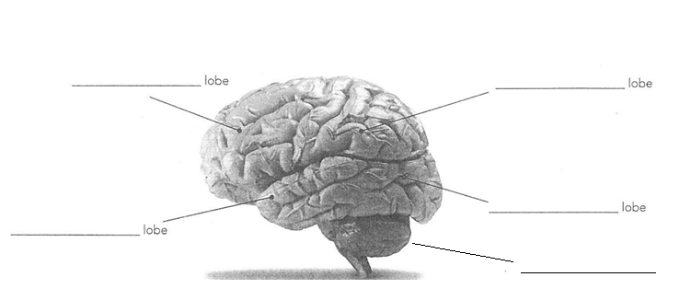
E
D
C
B
A
Structure | Structure Name | Function of structure
B

D

Question 3 [4 marks]
A person has a brain injury and starts to lose fine motor coordination of his muscles and walks as if he is drunk. He also finds he keeps bumping into objects. Name the two parts of the brain that have been affected by the injury and explain your choices.
________________________________________________________________________________________________________________________________________________________________________________________________________________________________________________________________________________________________________________________________________

Question 4 [8 marks]
- Identify the structure of a neuron shown by the labels in the illustration below. (3 marks)
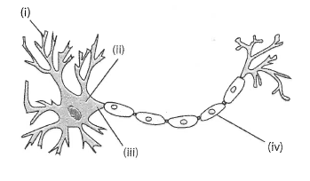

Structure of a neuron

- ______________________________________________________________
- ______________________________________________________________
(iv) ______________________________________________________________

- Describe the purpose of the structure labelled at (iv) in part (a). (1 mark)

____________________________________________________________________
____________________________________________________________________
- Label (iii) is the axon. Describe the function of the axon. (2 marks)

____________________________________________________________________
____________________________________________________________________
- Draw an ARROW to show the direction of the impulse along this neuron. (1 mark)

- What type of neuron does this diagram depict? (1 mark)

______________________________________________________________________

Question 5 [7 marks]
Label the following diagram. (3 marks)

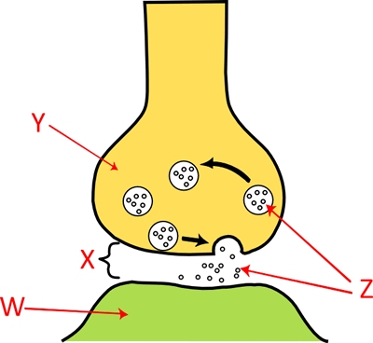
X __________________________________

Y__________________________________

Z ___________________________________

b. Name ONE neurotransmitter that could be released from a vesicle in the brain. (1 mark)
______________________________________________________________________
c. Briefly explain how the neurotransmitter allows communication of an impulse to be transferred from one neuron to another. (3 marks)

________________________________________________________________________________________________________________________________________________________________________________________________________________________________________________________________________________________________________________________________________________________________________________________________________________

Question 6 [6 marks]
Drugs can have many effects on the nervous system and therefore on the psychological and physiological functions of the body.
Describe ONE psychological effect and ONE physiological effect on the body of the following drug types, AND give ONE example of each.

- Stimulant: ____________________________________________________________________________________________________________________________________________________________________________________________________________________________________
- Depressant: __________________________________________________________________________________________________________________________________________________________________________________________________________________________________
Question 7 [7 marks]
Researchers use various types of technology that assist them to understand the brain.
- Describe the use of EEG (electroencephalography) to investigate brain activity. (3 marks)
_____________________________________________________________________________
_____________________________________________________________________________
_____________________________________________________________________________
- Describe two differences between MRI scans and PET scans. (4 marks)
_____________________________________________________________________________
_____________________________________________________________________________
_____________________________________________________________________________
_____________________________________________________________________________
_____________________________________________________________________________
_____________________________________________________________________________

Question 8 [6 marks]
Split brain studies were conducted by Roger Sperry, in which the band of fibres between both hemispheres is severed to try to reduce symptoms in in patients with severe epilepsy. These studies have been used to explain how the left and right hemispheres function.
- List FOUR (4) functions of the left hemisphere of the brain. (4 marks)
____________________________________________________________________________________________________________________________________________________________________________________________________________________________________________________________________________________________________________________________
- Name the collection of white myelinated nerve fibres that joins the two hemispheres of the cerebrum, and state the function of this structure. (2 marks)
_____________________________________________________________________________________________________________________________________________________________________________________________________________________________________________

